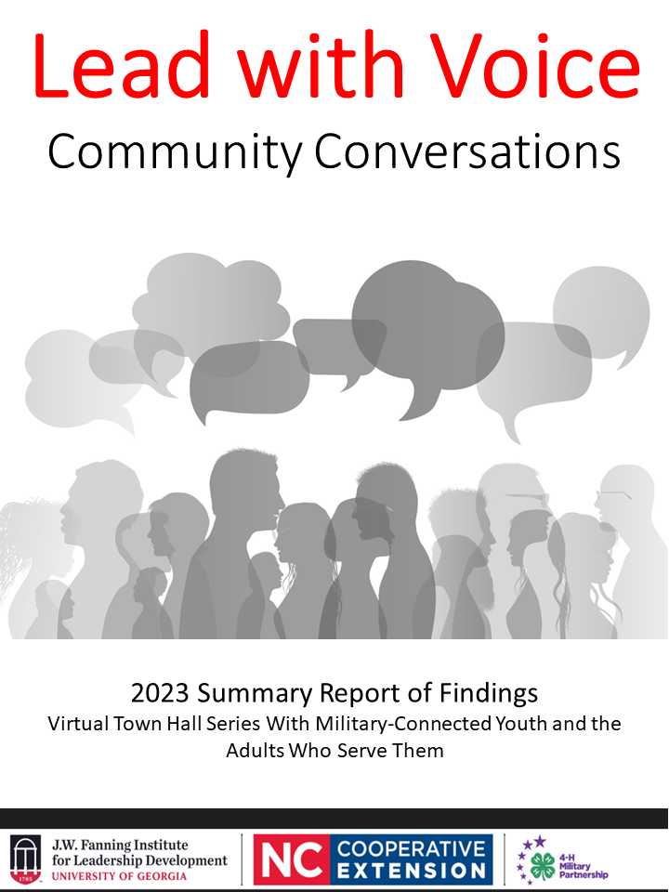

Prepared for:
4-H Military Partnership
North Carolina State University Cooperative Extension

Prepared by:
Jason Estep, J.D.
Lauren Healey, M.S.
Lori Tiller, Ph.D.
Emma Bennett, Student

For more information, contact:
J.W. Fanning Institute for Leadership Development
University of Georgia
1240 South Lumpkin St.
Athens, GA 30602
Phone: 706-542-1108
www.fanning.uga.edu

Lead with Voice: Community Conversations

In February 2023, the 4-H Military Partnership via North Carolina State University Extension and the University of Georgia’s J.W. Fanning Institute for Leadership Development partnered to host a series of virtual youth/adult town hall meetings. The series was called Lead with Voice: Community Conversations. The purpose for hosting these town hall meetings with military-connected youth was to learn about their concerns and engage them in civic discourse. Furthermore, the results, summarized here, will be used to promote youth voice in programming and policy decisions across the 4-H Military Partnership and within local communities serving military-connected youth.

Three town halls were conducted to discuss the challenges, opportunities, and innovations that have arisen during the past couple of years. The invited youth participants were all military-connected, and the adult participants were invited because they help serve military-connected youth in their community, either directly or indirectly. The diverse insights, experiences, and influence of both the youth and adult participants were essential to the success of the town halls.

The town hall programs each consisted of two parts – a breakout session where the youths and adults were moved into separate virtual spaces to respond to a series of questions, followed by a plenary session where the groups shared overviews of their conversations with one another. In the first part, youth were divided into smaller discussion groups and placed in virtual breakout rooms. The youth breakout rooms were led by youth facilitators, when possible, with an adult facilitator acting as scribe to keep detailed notes while protecting the confidentiality of participants. The following 5 questions were posed to the youth, and as noted below, an additional probing question or two was also prepared and may have also been posed to students to increase clarity or to encourage additional responses:

- What is something significant that has changed for you in the past two years?
Probing question: What is something good/a positive change that happened? Something that makes you proud?
- What has been your largest source of stress over the past year?
Probing question: At home, with friends, with school?
Acute or generalized? (e.g., did this happen to you/someone you know, or are your stressors more general?)
- What do you need from the adults in your life in order to feel supported and set up for success?
Probing question: From your parents? Educators? Youth program leaders? Etc.?
- How have your feelings about school changed over time?
Probing question: Are you as engaged now as you once were? More engaged? What do you appreciate about school? What things about school cause you anxiety or negative feelings?
Does being a military connected youth bring a unique perspective to that?
- What would you like the adults in your life to know and understand about your experience as we move forward?
Probing question: Describe how being military connected has shaped your experience.

While the youth were in their breakout room, the adult participants remained together in the main room for discussion facilitated by Fanning Institute faculty members. Again, detailed notes of participant responses were taken without identifying particular respondents. As with the youth, 5 questions were posed to the adults:

- What is something that changed for you in your youth practice during the past three years that you hope will continue?
- What has been the greatest challenge that you’ve seen the youth in your program struggle with during the past two years?
- What would you want the youth you work with to know and understand about your experience as we move forward?
- Any success stories you could share about getting youth back involved with in-person programming?
- What questions do you have for each other?

Then, in the second part, the youth and adults were brought back together in the main Zoom® room. Representatives of each group were asked to share some of the highlights from their breakout group discussions. In all sessions, detailed notes were taken while protecting the confidentiality of participants.

By including and focusing on military-connected youth, these community conversations served to promote youth voice within the 4-H Military Youth Partnership. When youth are given a voice in the decision-making process, they feel empowered and valued. After all, youth are the experts on their own experiences, and their perspectives are invaluable in shaping programs and services to meet their needs. Never underestimate the creativity and innovation of young people -- their ideas can lead to new approaches and solutions that may not have been considered otherwise. Lastly, encouraging youth voice can foster increased civic engagement and a sense of responsibility to their communities. By involving youth in these dialogues, we can ensure that the programs and services designed to serve them are more effective, relevant, and responsive to their needs.

Descriptive Statistics of Participants
In total, 41 people participated across three town halls. 23 of those participants were military-connected youth, and 18 were adults who serve military-connected students. The participants lived in various places across the United States, primarily in the continental United States, but with at least one participant currently based in Puerto Rico. Two-thirds of the participants were female and one-third male, and 94.44% identified as not of Hispanic, Latino, or Spanish origin. A voluntary evaluative survey was made available to participants, of whom 22 responded, providing the following information about themselves:

Results and Findings

Perceptions Regarding Town Hall Format and Learnings
Respondents all agreed that the session aligned with their expectations. Overall, 94.45% of participants either agreed or strongly agreed that the townhall goals were clearly communicated, was worth the time invested, and found the breakout room discussions helpful. 88.89% felt that the facilitators did an adequate job encouraging the exchange of ideas and experiences. However, there was a small number of participants who disagreed that the goals were clearly stated (1), was worth the time invested (1), and that the facilitators were able to facilitate an exchange of ideas (2). Indeed, out of all respondents, only one said they would not consider participating in a similar session on a different topic in the future.

When asked if they had gained a better understanding of the perspectives of others, 50% of respondents strongly agreed and an additional 44.44% agreed with the statement. There was only one person who stated that they had not gained any insight into the perspectives of others. More importantly, 89% of the participants did agree that they were able to connect with new people.

Looking to the long-term implications of a townhall series like this, while most people said that they would share something from the townhalls with others within 6 months (83.33% agreed or strongly agreed), 16.67% felt that they would not share anything from the town halls within six months.

Respondents were asked to complete this statement: “An important takeaway from today’s session is…” Below are several exemplary responses:

“Do not hesitate to talk to adults about any expectations or other views that they may put on you.”
“Life is going to throw hurdles. Adults and teens need to cooperate with each other in order to push through those obstacles and challenges.”
“...that you are not alone, and that we should speak up for the change we want to see.”
“I got to speak my mind and felt like I was heard”
“We all have similar experiences and needs - I think together we can come up with best practices!”
“Youth are facing difficulties transitioning back to "normal" life, but as professionals we can take steps to support that transition and make youth feel heard.”
“The struggle is real. Loved the question about success stories and giving details in how they were successful so other may replicate it and make impact in their areas or programs.”
“Military youth are so resilient; I need to be more intentional about engaging the military teens I work with in conversations about what is happening in the world. Creating more opportunities and experiences for them to bring their voice to the table; to share their views; concerns; and have meaningful conversations about what is important to them and hearing the questions and concerns they are shouldering. Our teens are amazing!”
“Don’t be afraid to share with others, don’t be afraid to open up.”

Youth Breakout Rooms
The youths were put into breakout rooms where they discussed changes and stressors from the past two years, effective adult support, opinions on school, and what they wanted the adults in their lives to understand about their experiences.

Key Takeaways
Youth responses during their breakout sessions can be distilled into three themes:
- Parental expectations cause stress over current and future performance (especially academic)
- Craving validation, transparency, and guidance from adults during these uncertain times (Youth often feel like they are not being given the whole truth about what’s going on in their lives and in the world, regardless of the reasoning, and this only increases their anxiety.)
- Experiencing uncertainty and anxiety over how to socially interact with others

Summary of Youth Responses
Significant changes from the past two years:
- Loss of family members
- Participating in new extracurriculars
- Starting a new job
- Transitioning back to school after COVID-19
- Moving

Largest source of stress over the past year:
- Parental expectations causing stress over grades, which can make it hard to spend time with friends
- Disappointment over grades due to increasingly difficult classes
- Struggling to remain motivated with school work
- Family situations
- Preparing for college -- financially and emotionally
- Feeling isolated since the pandemic, almost trapped
- Social anxiety, feeling the need to impress others
- Unsure about future, specifically what to do for a career

What they need from adults to feel supported and set up for success:
- Feeling accepted and not judged
- Understanding that growing up is different for youth than it was for parents
- Being trusted with more responsibility
- Mentorship and guidance on how to fulfill expectations, how to apply for a job, and help with school work
- Healthy communication from counselors, siblings, and parents

Their feelings on school over time:
- Enjoying seeing their friends every day and having people to go through life with them
- Feeling uncomfortable because of social anxiety, feel as though they have lost the ability to be social
- Grateful for teachers that make school fun and help them learn
- Noticing monotony in every school day
- Frustration over memorizing information for a test only to forget it after
- Appreciative of the new opportunities high school offers

What they would like adults to know:
- Youth want their feelings to be validated and heard
- Better communication allows feelings to be freely discussed
- Understand that processing emotions can take more time for youth than adults
- Readjust expectations to be more achievable

Adult Breakout Rooms
The adults were put into a separate breakout room where they discussed changes and stressors in their youth practice over the last three years, what they want the youth to understand about their personal experiences, and finally shared success stories about transition back to in-person programming.

Key Takeaways
Adult responses during their breakout sessions can be distilled into three themes:
- Widespread loss experienced by youth, from significant milestones and experiences, to loved ones, to relationships with students who moved during the pandemic
- Virtual offerings both helped and hurt youth programs
- Scale of social interaction, with some desperate to return to in-person events and some struggling to transition back

Summary of Adult Responses
Significant changes from the past three years:
- Technology usage, from Zoom to social media, to help maintain connections and advertise youth events
- Greater capacity to offer more education and resources virtually
- Praise for youth’s resilience and positive behavior. Quieter kids felt more comfortable participating virtually and became more outspoken

Other considerations from past three years:
- Understaffing across youth programs that virtual connection could not make up for
- Youth that transferred/moved during the pandemic were essentially lost because of the difficulty of connecting with them

Largest challenge for youth during the past two years:
- In-person social skills became strained due to social distancing guidelines, and some youth are struggling to transition back
- Isolation also led to overuse of technology, creating greater opportunity for online bullying while also causing youth to disengage from “normal” activities
- Lack of access to support for mental health while experiencing increasing rates of depression and anxiety
- The loss of family members, relationships, and normal milestones (graduation, dances, sports, etc.)

What they want youth to understand:
- Adults have been struggling with COVID-19 and the transition back, too. Adults don’t have everything figured out, either
- Adults want to be there for the youth; they are genuinely concerned about their well-being and want to support them in whatever way is best
- It gets better. Hope and positivity are important at this time but that doesn’t mean you’re not allowed to grieve. Look past the pandemic to a better future
- Continue to maintain connections. Relationships are precious and should not be taken for granted

Success stories about transition:
- Student ambassadors have done a great job of supporting the other youth and coming up with ideas to increase engagement
- Building on programs that are still flourishing and encouraging leaders to continuously reach out to students
- Personal connection and invitation goes a long way. It’s a lot harder for youth to say no over the phone or in person. Also found success with thank you notes
- Encouraging older youth to come back and help with programs
- Making some meetings mandatory to attend in person and others virtually (hybrid approach)
- Acknowledging people’s scheduling needs by opening a program on the weekend or at times that work better with parents’ work schedules
- Special interest programs that are short and focused
- Building connections with youth through the community, such as community service
- Providing consistently for the youth, offering a familiar, stable place to come back to
- Getting staff to buy into the process so they actually invest in the youth
- Raising awareness of youth practices to parents; getting parents involved so that they would get their kids involved

Recommendations & Next Steps
Following the conclusion of the town halls, the youth and adult responses were themed and key takeaways reviewed for opportunities to engage further. While we did not have the youth attendance we had hoped for in the three town halls, those that attended were candid and shared what was really working for them. It was important for them to share their voices and to be heard by the adults present for the discussions. Given the perception data, participants found the town hall concept worked well. It provides a chance for youth and adults to have a strong discussion separately, and then to share the highlights together to see where similarities and opportunities for further work might bubble up in the joint discussions.

It is reassuring that what the adults identified as some of the greatest struggles being faced by youth largely aligned with what the youth, themselves, reported as their greatest challenges following the three years of the pandemic and lack of in-person contact. This is evidentiary of a foundation of positive relationships and strong communication between youth respondents and the caring adults who support them. It was also encouraging that one recommendation made by both youth and adults is for increased and continued open and regular dialogue that allow youth to share their feelings and that provide adults the opportunity to make youth feel heard by adapting their programming and policies in response to youth suggestions and concerns.

One way to accomplish this recommendation is to host local in-person or virtual town-hall-style forums similar to the format used for these discussions. To that end, a DIY Town Hall Toolkit has been developed by the Fanning Institute that includes step-by-step instructions and helpful resources to assist adults in increasing youth voice. This toolkit can be branded and made available across all five military branches and teen centers.

As the teen centers continue to re-open and provide more opportunity for in-person programming, it is important to offer opportunities for youth and adults to continue to engage with each other. We recommend including focused dialogue time in conjunction with an already scheduled youth event as an easy way to ensure healthy participation. If the students are already engaging in specific teen center events, adding a component for food and dialogue is a way to show that the adult supporters are interested in continuing the dialogue and creating a space for the youth to continue to grow their voice.

